Practical 7 | MISSIONARIES AND CANNIBALS | Date: 00/07/2025
Aim: | To implement missionaries and cannibals
Requirement: | Python IDE
Code: | 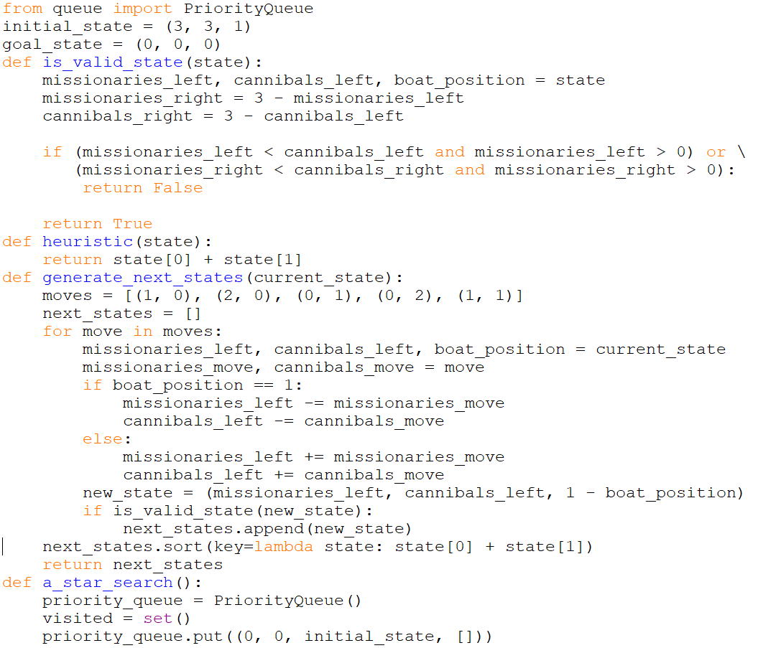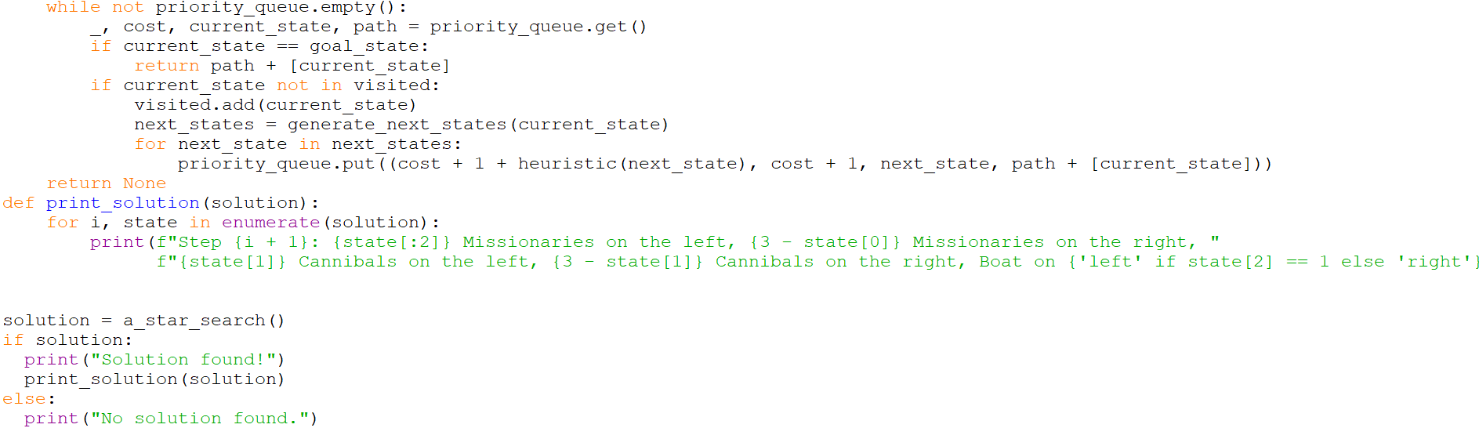
Screenshots: | 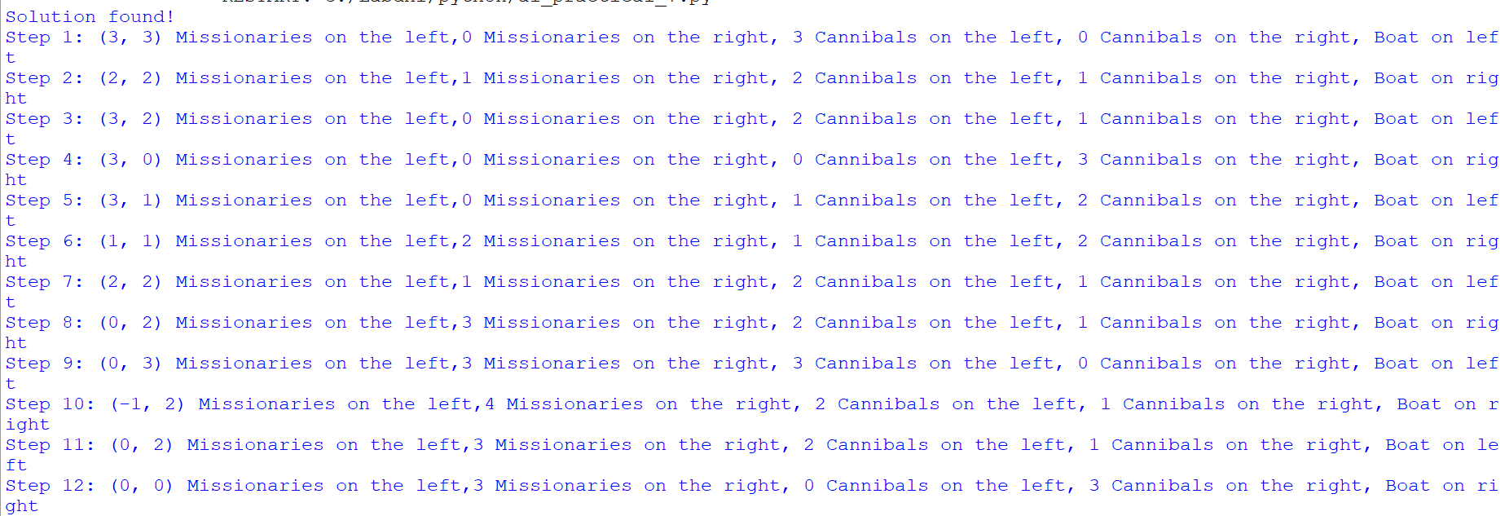
Result: | missionaries and cannibals has been implemented using python.
Date of Submission: |  | Sign:

